Project Title: Daily Expense Management System
Employee Name: Nisanth Saravanan
Employee ID: 12576

Description:
It is one of the needy applications to maintain the details of expenditure we do on our daily life. Details of the total amount spent and description for each will be shown with time. Also provides a filter option to view expense in last week, last month along with the graphical representation for knowing the expense hikes. Comparison of expense amount with different months is possible here.

Modules Required:
- User Module.
- Expense Manager Module.
- Admin Module.

Project Title: Daily Expense Management System
1. What? |  | 2. How?
1. What are the necessary modules?  Ans: Modules Required:  - User Module.  - Expense Manager Module.  - Admin Module.  2. What are the functionalities of User Module?  Ans: User Module:  - User can login to their Dashboard.  - User can edit their personal information.  - User can change their password.  - User can edit their expenditures.  - User can browse old expenditures.  - User can compare expenditure.  - User can generate expenditure graphical reports.  4. What are the functionalities of Expense Manager Module?  Ans: Expense Manager Module:  - Expense Manager can view expenditures.  - Expense Manager can generate reports.  - Expense Manager can store and load expenditures.  4. What are the functionalities of Admin Module?  Ans: Admin Module:  - Admin can login to their Dashboard.  - Admin can edit their personal details.  - Admin can change their password.  - Admin can edit About Us page.  - Admin can view and answer user queries.  - Admin can manage user permissions. |  | 1) User:  a) User can login to their Dashboard:  Method 1: User can use phone number for login.  Method 2: User can use social media accounts.  Method 3: User can use mail id for login.  b) User can edit their personal information:  Method 1: Information can be edited in a pop-up window.  Method 2: Information can be edited via a simple form.  Method 3: Information can be edited in a modular form.  c) User can change their password:  Method 1: Password can be reset via an emailed link.  Method 2: Password can be changed via phone number.  Method 3: Password can be changed in the user profile itself.  d) User can edit their expenditures:  Method 1: Expenditures can be edited in a calender type form.  Method 2: Expenditures can be formatted a queue.  Method 3: Expenditures can be formatted as a simple list.  e) User can browse old expenditures:  Method 1: Browsing can be done via filters and categories.  Method 2: Browsing can be done by date and time.  Method 3: Browsing can be done via a dedicated search bar.  f) User can compare expenditure:  Method 1: Comparison view can be tabular.  Method 2: Comparison view can be pop-up window.  Method 3: Comparison view can be viewed under a dedicated window.  g) User can generate expenditure graphical reports:  Method 1: Reports can be detailed and in a downloadable format.  Method 2: Reports can be detailed but, can only be viewed in the system.  Method 3: Reports can be listed in a dedicated window.  2) Expense Manager System:  a) Expense Manager can view expenditures:  Method 1: The details are viewable in rich text format.  Method 2: The details are viewable in date-wise arrangement.  Method 3: The details are viewable in a queue format.  b) Expense Manager can generate reports:  Method 1: The reports should be detailed and should contain graphical statistics.  Method 2: The reports should contain purely analytical results as rich formatted text.  Method 3: The reports should be a simple overview of user expenditure trends.  c) Expense Manager can store and load expenditures:  Method 1: Can be stored and loaded by using queue.  Method 2: Can be stored and loaded using a calender like format.  Method 3: Can be stored and loaded as a list.  c) Admin:  a) Admin can login to their Dashboard:  Method 1: Admin can use phone number for login.  Method 2: Admin can use social media accounts.  Method 3: Admin can use mail id for login.  b) Admin can edit their personal information:  Method 1: Information can be edited in a pop-up window.  Method 2: Information can be edited via a simple form.  Method 3: Information can be edited in a modular form.  c) Admin can change their password:  Method 1: Password can be reset via an emailed link.  Method 2: Password can be changed via phone number.  Method 3: Password can be changed in the user profile itself.  d) Admin can edit About Us page:  Method 1: Editing can be done using basic HTML/CSS formatting.  Method 2: Editing can be done using React code.  Method 3: Editing can be don’t in a dedicated panel.  e) Admin can view and answer user queries:  Method 1: The Q&As can be performed in a dedicated window.  Method 2: The Q&As can be done in a pop-up panel.  Method 3: The Q&As can be done in the admin panel itself.  f) Admin can manage user permissions:  Method 1: Permissions can be edited in the admin panel.  Method 2: Permissions can be edited using a dedicated wizard.  Method 3: Permissions can be edited in the user’s profile.
1) User:  a) User can login to their Dashboard:  Method 3: User can use mail id for login.  - Covers all the basic concerns over security and availability during log in procedure.  b) User can edit their personal information:  Method 2: Information can be edited via a simple form.  - It’s sufficient to get necessary details from the user for their profile., and it’s also efficient.  c) User can change their password:  Method 1: Password can be reset via an emailed link.  - Covers all the basic concerns over security and availability during password reset in procedure.  d) User can edit their expenditures:  Method 1: Expenditures can be edited in a calender type form.  - Contains necessary means to store all required data such as date, time and a small description.  e) User can browse old expenditures:  Method 2: Browsing can be done by date and time.  - Helps for an effective searching as the data is stored with respect tot the date and time of expense.  f) User can compare expenditure:  Method 1: Comparison view can be tabular.  - A tabular structure help to clear view differences in the data and the changes in them over time.  g) User can generate expenditure graphical reports:  Method 1: Reports can be detailed and in a downloadable format.  - Allows for a flexible analysis and a shareable format for an expenditure report.  2) Expense Manager System:  a) Expense Manager can view expenditures:  Method 2: The details are viewable in date-wise arrangement.  - This allows for the data to be freely used in report generation, with no missing detail, and no trouble in accessing.  b) Expense Manager can generate reports:  Method 1: The reports should be detailed and should contain graphical statistics.  - Allows for a comprehensive report, that actually contains valuable insights.  c) Expense Manager can store and load expenditures:  Method 2: Can be stored and loaded using a calender like format.  - Allows for a flexible storing option, that is able to capture all necessary details.  c) Admin:  a) Admin can login to their Dashboard:  Method 3: Admin can use mail id for login.  - Covers all the basic concerns over security and availability during log in procedure.  b) Admin can edit their personal information:  Method 2: Information can be edited via a simple form.  - It’s sufficient to get necessary details from the user for their profile, and it’s also efficient.  c) Admin can change their password:  Method 1: Password can be reset via an emailed link.  - Covers all the basic concerns over security and availability during password reset in procedure.  d) Admin can edit About Us page:  Method 2: Editing can be done using React code.  - Allows flexible input and can accommodate future changes to any specific element in particular.  e) Admin can view and answer user queries:  Method 1: The Q&As can be performed in a dedicated window.  - Allows for a focused-view on the FAQs and can help in for a customer-first approach.  f) Admin can manage user permissions:  Method 1: Permissions can be edited in the admin panel.  - An efficient choice to have the permission control in the main dashboard of the admin. |  | 1) User:  a) User can login to their Dashboard:  - The availability of the phone number, and the security of the social media platforms are unreliable means for login.  b) User can edit their personal information:  - Pop-ups for getting input doesn’t provide for a streamlined UI, and there is no need to have a  modular form for a simple task.  c) User can change their password:  - The availability of the phone number, and the availability of an active session are unreliable means for password reset procedures.  d) User can edit their expenditures:  - Having the queued format is troublesome for access and retrieval, and a simple list can only store partial amounts for data.  e) User can browse old expenditures:  - Filters and categories bring out a broad set of results, and a search bar can not effectively work with respect date and time.  f) User can compare expenditure:  - Pop-ups do not provide well for a streamlined UX, and a dedicated window is rather unnecessary for a simple comparison view.  g) User can generate expenditure graphical reports:  - Having the reports in the system doesn’t allow the user to have a freely exportable format, and a dedicated window doesn’t have flexility for further analysis.  2) Expense Manager System:  a) Expense Manager can view expenditures:  - Viewing in rich text can not provide the complete data, and the queue format is troublesome for accessing.  b) Expense Manager can generate reports:  - Having a rich text output is not suitable for further analysis, and a simple overview is rather an inefficient way to present a report.  c) Expense Manager can store and load expenditures:  - Queue is troublesome for loading process for a prior date, and a simple list is inefficient.  c) Admin:  a) Admin can login to their Dashboard:  - The availability of the phone number, and the security of the social media platforms are unreliable means for login.  b) Admin can edit their personal information:  - Pop-ups for getting input doesn’t provide for a streamlined UI, and there is no need to have a  modular form for a simple task.  c) Admin can change their password:  - The availability of the phone number, and the availability of an active session are unreliable means for password reset procedures.  d) Admin can edit About Us page:  - HTML/CSS lacks flexibility, and a dedicated panel is rather an inefficient option.  e) Admin can view and answer user queries:  - Pop-up windows doesn’t provide for a streamlined UX, and having this functionality in the admin panel will be inefficient.  f) Admin can manage user permissions:  - Dedicated wizard is an inefficient approach, and having to navigate to a specific user profile is time-consuming if the number of users to edit I at large.
3. Why? |  | 4. Why Not?

Algorithm and Flow-Chart:
Algorithm: For Expenditure Storing And Loading and Deletion:

Step 1. Start.
Step 2. User Logs In.
Step 2.1 System verifies user login.
Step 3. System displays options.
Step 4. User chooses an option:
Step 4.1 IF STORING:
Step 4.1.1 Get Date from the User.
Step 4.1.2 Get Time from the User.
Step 4.1.2 Get Amount of Expense from the User.
Step 4.1.3 Get Description from the User.
Step 4.1.4 User clicks on Store Expense.
Step 4.1.5 System notifies upon completion of insertion.
END IF
Step 4.2 IF LOADING:
Step 4.2.1 Get Date from the User.
Step 4.2.2 User clicks on Load Expenses.
Step 4.2.3 System Loads all Expenditure on the “Date”.
Step 4.2.4 User views All Expenses on said “Date”.
END IF
Step 4.3 IF DELETION:
Step 4.3.1 Get Date from the User.
Step 4.3.2 System Loads all Expenditure on the “Date”.
Step 4.3.3 User selects a specific Expenditure.
Step 4.3.4 User clicks on Delete Expense.
Step 4.3.5 System notifies upon completion of deletion.
END IF
Step 5. Stop.
Flow-Chart: For Expenditure Storing And Loading and Deletion:

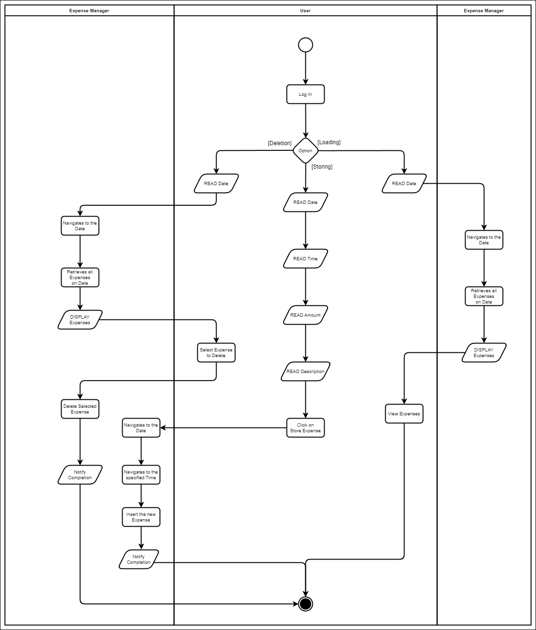

UML Diagrams:
Use-Case Diagram:

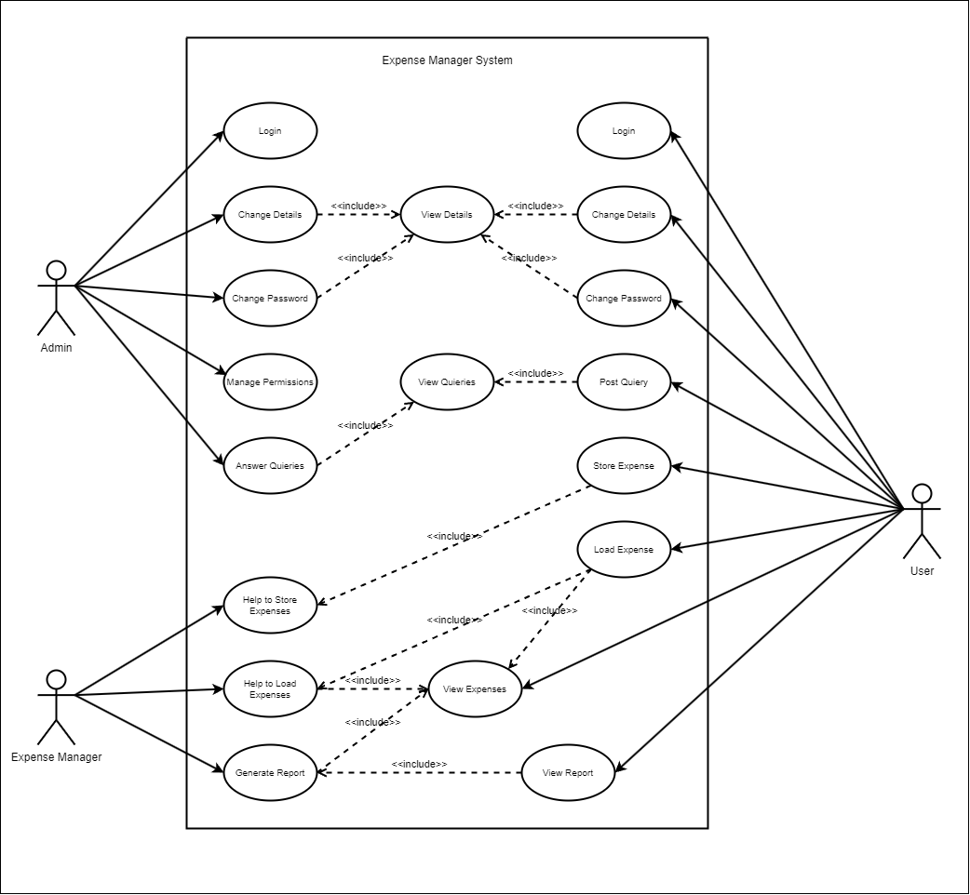

Class Diagram:

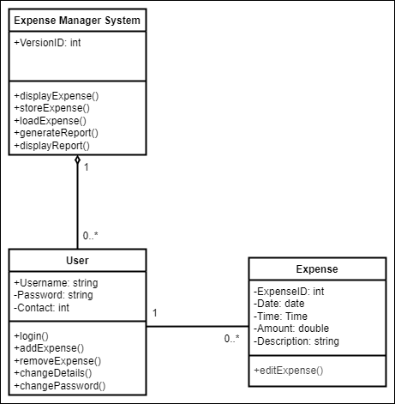
Sequence Diagram:

For Expenditure Storing And Loading and Deletion:

